Manual for D/A Conversion
- Function: Custom channel type by user
- Support model : H265 ADVR
- Usage
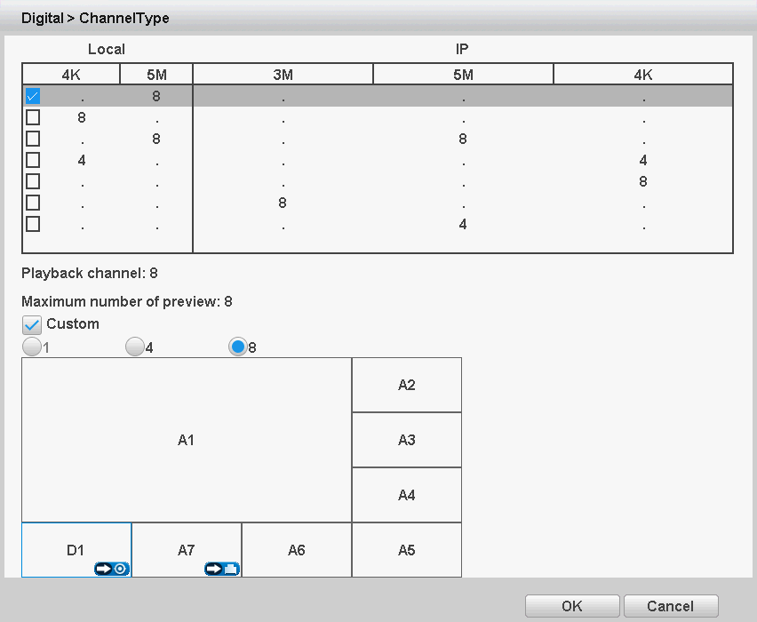
Such as the below picture shown, you could change the analog channel type A8 to digital channel type: Click the icon in A8,
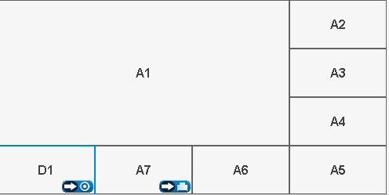
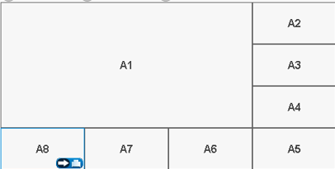

you can switch the digital type(D1) to analog type, click in D1,
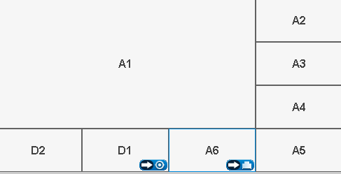
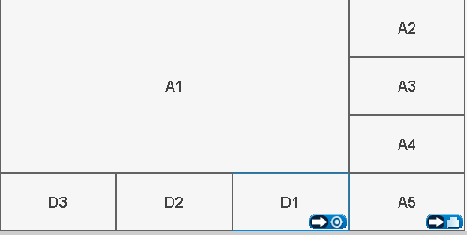

- Note:
- A means Analog(Local mode),D means Digital (IP mode)
- Most models’ local mode can support D/A conversion function, please refer to the specific model.

